

Acknowledgement:

Dubbo Regional Council wish to acknowledge the Wiradjuri People who are the Traditional Custodians of the Land. Council pay respect to the Elders past, present and emerging of the Wiradjuri Nation and extend that respect to other First Nations peoples.

**Planning Proposal**

Amendment to the Dubbo Regional Local Environmental Plan 2022

Making Residential Accommodation permissible in the E2 Commercial Centre zone

Council reference R24-004

ED25/162591

**Contents**

About this Planning Proposal 3

Part 1 Objectives and Intended Outcomes 3

Part 2 Explanation of Provisions 3

Part 3 Justification of Strategic and Site-Specific Merit 3

Section A – Need for the Planning Proposal 4

Section B – Relationship to the Strategic Planning Framework 4

Section C – Environmental, Social and Economic Impacts 7

Section D – Infrastructure 8

Section E – State and Commonwealth Interests 8

Part 4 Maps 8

Part 5 Community Consultation 10

Part 6 Project Timeline 10

# About this Planning Proposal

The Dubbo Regional Local Environmental Plan (LEP) 2022 regulates planning decisions in the Dubbo Regional Local Government Area through land and development controls such as zoning, minimum lot sizes, development standards and land use permissibility. To ensure it continues to deliver intended outcomes and meets the requirements of our community, Council is seeking to permit Residential Accommodation in the E2 Commercial Centre zone.

This planning proposal has been prepared in accordance with the NSW Department of Planning, Housing and Infrastructure – Local Environmental Plan Making Guideline, and identifies:

* Objectives and intended outcomes;
* Explanation of the provisions;
* Justification of strategic and site-specific merit;
* Justification of the proposed changes to the Dubbo Regional LEP 2022; and
* Project timeline.

A planning proposal must be endorsed by Council and the NSW Department of Planning, Housing and Infrastructure in order to take effect. This process must be undertaken in accordance with Division 3.4 of the Environmental Planning and Assessment Act 1979.

# Objectives and Intended Outcomes

The objective of this planning proposal is to make boarding houses, co-living housing, multi-dwelling Housing, Residential Flat Buildings and Senior Housing land uses permitted with consent in the E2 Commercial Centre zone, which is the Dubbo and Wellington Central Business Districts. Permitting Residential Accommodation will assist in providing additional housing supply, including for temporary workers, and help activate the Dubbo CBD outside normal business hours. Residential Accommodation is permitted with consent in the Wellington CBD through an additional permitted use.

# Explanation of Provisions

This planning proposal will amend the Dubbo Regional LEP 2022 in the following ways:

* amend the Land Use Table – Zone E2 Commercial to make boarding houses, co-living housing, multi-dwelling housing, residential flat buildings and seniors housing permitted with consent; and
* retain Schedule 1 – Additional Permitted Use 18: Use of certain land at Wellington as “Development for the purposes of residential accommodation is permitted with development consent”

# Justification of Strategic and Site-Specific Merit

The planning proposal has been assessed against the following Council strategies, policies and guidelines, the NSW Department of Planning, Housing and Infrastructure’s Local Environmental Plan Making Guidelines, State Environmental Planning Policies, and Ministerial Directions.

* Central West and Orana Regional Plan 2041;
* Dubbo Regional Council – Towards 2040 Community Strategic Plan;
* Dubbo Regional Council – Local Strategic Planning Statement;
* Dubbo Urban Areas Development Strategy;
* Ministerial Directions; and
* State Environmental Planning Policies

The assessment indicates the proposal has strategic merit and should be submitted to the NSW Department of Planning, Housing and Infrastructure for a Gateway Determination.

## Section A – Need for the Planning Proposal

| **Question** | **Considerations** |
| --- | --- |
| Is the planning proposal a result of an endorsed LSPS, strategic study or report? | The planning proposal is not the result of any LSPS, strategic study or report.  Council’s Short-term Accommodation Study, which was presented to Council on 10 March 2023, recommended ‘investigating incentives for the development of shop top housing and residential flat buildings’. |
| Is the planning proposal the best means of achieving the objectives or intended outcomes, or is there a better way? | A planning proposal is the best way to achieve these goals as they involve modifying development controls in the Dubbo Regional LEP 2022. |

## Section B – Relationship to the Strategic Planning Framework

| **Question** | **Considerations** |
| --- | --- |
| Will the planning proposal give effect to the objectives and actions of the applicable regional or district plan or strategy (including any exhibited draft plans or strategies)? | **Central West and Orana Regional Plan 2041**  The planning proposal is consistent with the Central West and Orana Regional Plan 2041’s (CWORP 2041) objectives. The relevant objectives are:   * Objective 9: Ensure site selection and design embraces and respects the region’s landscapes, character and cultural heritage * Objective 11: Strengthen Bathurst, Dubbo and Orange as innovative and progressive regional cities * Objective 12: Sustain a network of healthy and prosperous centres * Objective 13: Provide well located housing to meet demand * Objective 14: Plan for diverse, affordable, resilient and inclusive housing * Objective 16: Provide accommodation options for seasonal, temporary and key workers   Permitting Residential Accommodation in the E2 Commercial Centre zone will enhance Objectives 9, 11, 12 and 13 by promoting development in the Dubbo CBD which will ensure that it remains the heart of the Dubbo community. This amendment will also enhance objectives 14 and 16 by providing more diverse housing options in Dubbo, and help meet the demands created by changing demographics of the region. |
| Is the planning proposal consistent with a council LSPS that has been endorsed by the Planning Secretary or GSC, or another endorsed local strategy or strategic plan? | The planning proposal is consistent with the Planning Priorities of the Dubbo Local Strategic Planning Statement (LSPS). The relevant Planning Priorities are:   * Priority 4: Reinforce the town centres of Wellington and Dubbo * Priority 9: Provide diversity and housing choice to cater for the needs of the community * Priority 10: Improving the affordability of housing * Priority 12: Create sustainable and well-designed neighbourhoods |
| Is the planning proposal consistent with other local government strategies? | **Urban Areas Strategy**  The planning proposal is consistent with all aspects of the Urban Areas Strategy, including the Employment Lands Strategy and the Residential Lands Strategy.  *Employment Lands Strategy*  The planning proposal is consistent with the overall objectives and intent of the Dubbo Employment Land Strategy. The strategy identifies the following opportunities:   * Planning controls are reviewed to encourage urban renewal and new residential development in the CBD * Alternative forms of transport should be encouraged for access around the CBD area, including non-motorised and renewable options * Consider how access and manoeuvrability for vehicles, pedestrians, cyclists and disabled can be improved throughout the precinct * Facilitate alternative and short-term activities (such as placemaking) that add to the vibrancy and activity in the CBD * Encourage through urban design guidelines, the provision of mixed use and shop top housing to increase activity * Ensure the CBD is maintained as the primary centre within the commercial centres hierarchy   The planning proposal will help to realise these opportunities by rejuvenating the CBD. It will also enable more residents to use active transport to get to the CBD by providing housing within walking distance. Having a resident population in the Dubbo CBD will increase activity, and strengthen the CBD’s role as the primary commercial centre.  *Residential Areas Strategy*  The planning proposal is consistent with the overall objectives and intent of the Dubbo Residential Areas Development Strategy. The Residential Areas Strategy identifies that:   * The provision of residential options in a “city” living environment is essential in realising the aims of strategy 6 in the Dubbo 21 Plan * The “city” professional groups and those preferring minimum maintenance with maximum access to the CBD must be satisfied in their accommodation choice in the Inner Urban area   At the time the Residential Areas Strategy was developed, medium density housing was permitted with consent in the Dubbo CBD.  *Wellington Settlement Strategy*  The planning proposal is consistent with the Wellington Settlement Strategy, as there will be no changes to permissibility in the area.  *CBD Precincts Plan*  The planning proposal is consistent with the community priorities of the CBD Precincts Plan to have City Centre Activation, and to provide opportunities for Growth and Development.  Providing residential accommodation in the Dubbo CBD will create after hours activation opportunities. It will also create opportunities for development in the CBD, and will provide local businesses with a larger customer base. |
| Dubbo Regional Local Environmental Plan 2022 | The planning proposal aligns with the following objectives of the E2 Commercial Centre zone:   * Enable residential development only if it is consistent with Council’s strategic planning for residential development in the area * High level of accessibility and amenity, particularly for pedestrians * To ensure that new development provides diverse and active street frontages to attract pedestrian traffic and contribute to vibrant, diverse and functional streets and public spaces   Permitting residential development is consistent with Council’s strategic objectives to drive urban renewal in the Dubbo CBD, as well as to provide more housing diversity.  Residential accommodation in the Dubbo CBD will also improve the accessibility of the town centre, particularly for pedestrians, by giving more people the option to walk to the shops. This will also add to the diverse and vibrant public spaces in the CBD by increasing pedestrian traffic in the CBD, which will provide an economic incentive for further commercial development.  The E2 Commercial Centre zone will still differ from the MU1 Mixed Use zone. The objectives of the MU1 zone are about creating a transition from the Dubbo CBD to the surrounding suburbs, whilst the E2 zone’s objectives are designed to create a central hub for Dubbo. |
| Is the planning proposal consistent with any other applicable State and regional studies or strategies? | **Other State or Regional Strategies**  There are no other relevant State or regional studies or strategies. |
| Is the planning proposal consistent with applicable SEPPs? | The planning proposal is consistent with the following SEPPs:   * Housing * Transport and Infrastructure |
| Is the planning proposal consistent with applicable Ministerial Directions (section 9.1 Directions)? | The planning proposal is generally consistent under the following Ministerial Directions:   * 1.1 Implementation of Regional Plans * 1.3 Approval and Referral Requirements * 1.4 Site Specific Provisions * 4.1 Flooding * 5.1 Integrating Land Use and Transport * 6.1 Residential Zones * 7.1 Employment Zones   The planning proposal is consistent with direction 1.4 as it will allow development to be undertaken in the zone and not rely on an additional permitted use for the Wellington CBD.  The planning proposal is consistent with direction 7.1 as it aligns with the objectives of the E2 Commercial Centre zone to enable residential development in the centre, as well as increasing accessibility and ensuring that the Dubbo CBD continues to be the commercial centre of the region. |

## Section C – Environmental, Social and Economic Impacts

| **Question** | **Considerations** |
| --- | --- |
| Is there any likelihood that critical habitat or threatened species, populations or ecological communities, or their habitats, will be adversely affected because of the proposal? | This planning proposal will have no environmental impact as it only impacts existing urban areas. |
| Are there any other likely environmental effects of the planning proposal and how are they proposed to be managed? | This planning proposal will have no environmental impact as it only impacts existing urban areas. |
| Has the planning proposal adequately addressed any social and economic effects? | This planning proposal will have positive economic and social impacts.  Permitting Residential Accommodation in in the E2 Commercial Centre zone will activate commercial precincts outside of business hours, and will provide a larger immediate customer base for local businesses. This is anticipated to stimulate the local economy.  Residential accommodation is currently permitted in the Wellington E2 commercial centre zone under Additional Permitted Use 18 with no negative economic effects on the Wellington CBD.  There is existing residential accommodation in the E2 zone in both Dubbo and Wellington. Medium-density housing was permitted with consent in the Dubbo CBD until the Dubbo Local Environmental Plan 2011 came into force. |

## Section D – Infrastructure

| **Question** | **Considerations** |
| --- | --- |
| Is there adequate public infrastructure for the planning proposal? | The planning proposal will not create additional demand for public infrastructure as it is not site-specific, and it will enhance the relevant zone objectives. Access to public infrastructure will still be assessed at the development application stage. |

## Section E – State and Commonwealth Interests

| **Question** | **Considerations** |
| --- | --- |
| What are the views of state and federal public authorities and government agencies consulted in order to inform the Gateway determination? | State and Commonwealth public authorities will be consulted in accordance with the Gateway determination and will be given at least 30 days to comment on the proposal. |

# Maps

The planning proposal is not changing any existing maps and will continue to allow Additional Permitted Use 18 in the mapped areas.

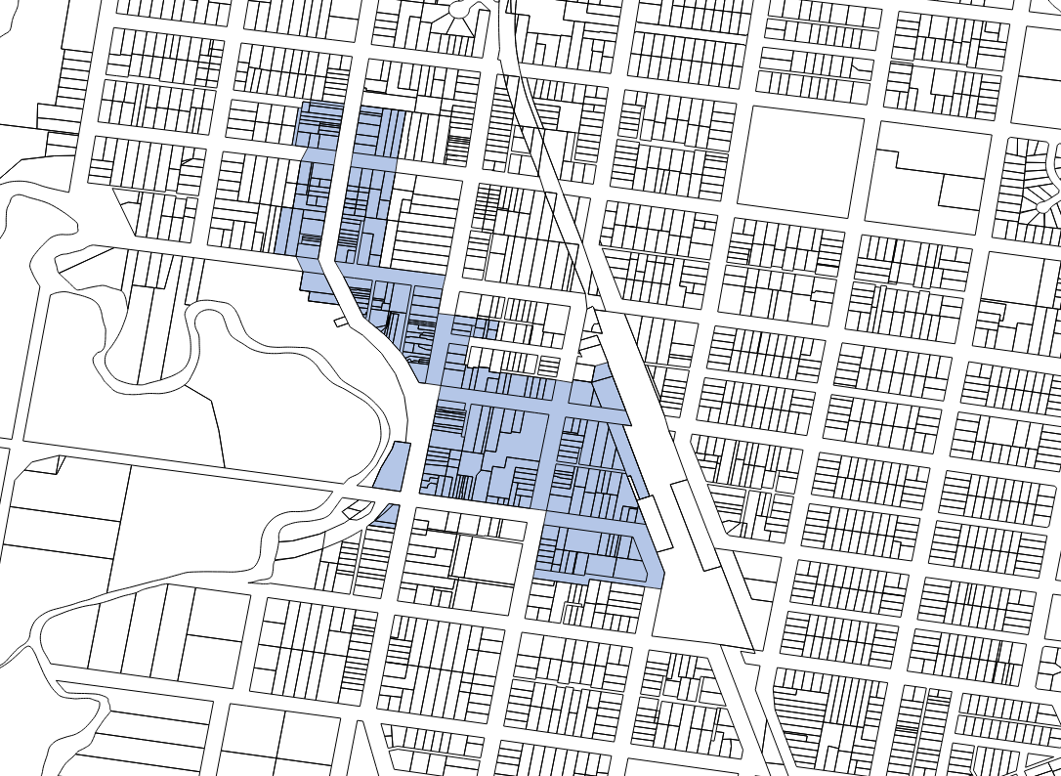

**Figure 1**: E2 Commercial Centre zone in Wellington.

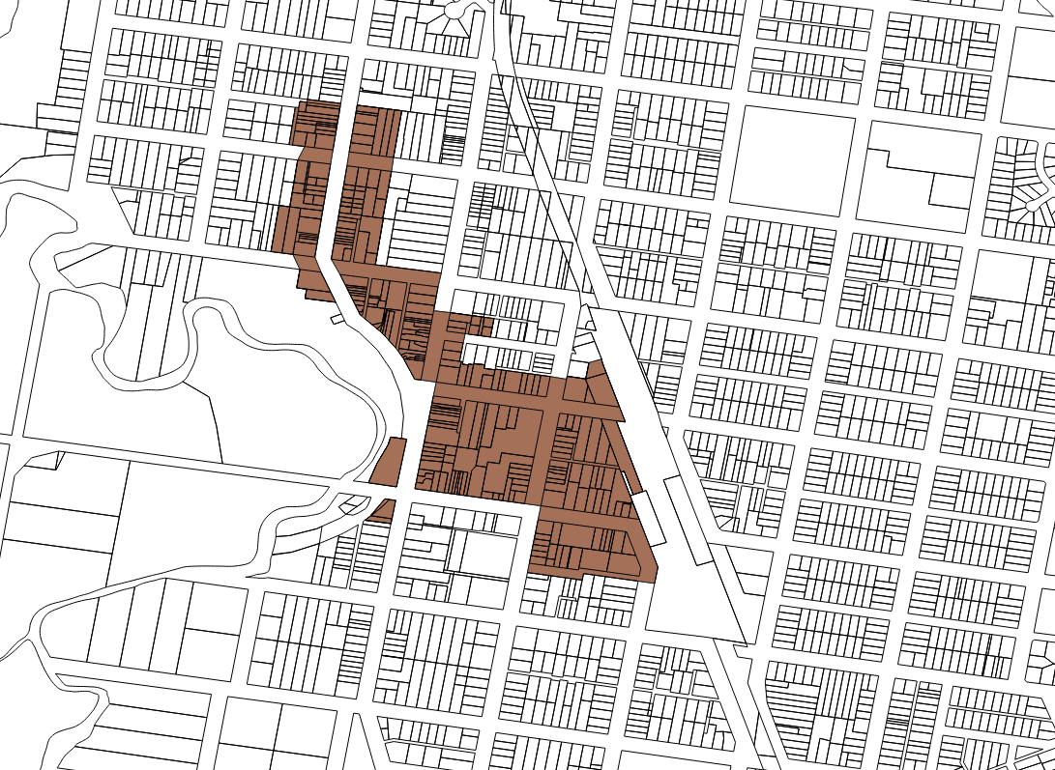

**Figure 2**: Additional Permitted Use 18

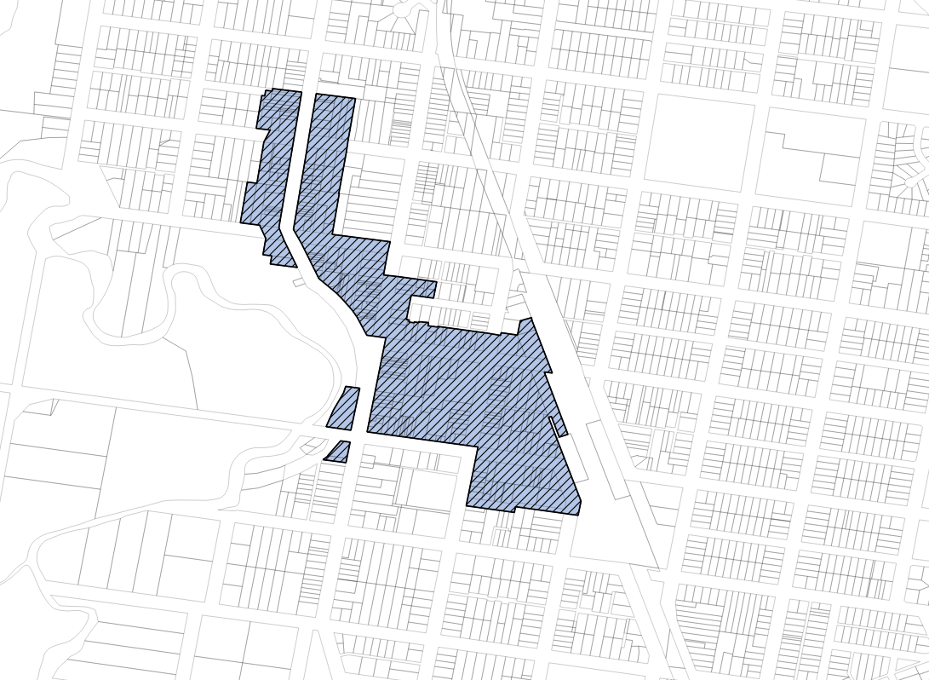

**Figure 3**: Overlap between E2 zone and APU 18

# Community Consultation

Community consultation will be undertaken in accordance with the Gateway Determination.

The planning proposal will be publicly exhibited for a minimum of 20 business days, will be placed on public exhibition in the following ways:

* Published on Council website
* Physical copies and Council’s Customer Experience Centres
* Physical copies at the Macquarie Regional Library
* Column in the Daily Liberal newspaper
* Published on the NSW Government Planning Portal
* Notification to relevant State Agencies

# Project Timeline

The below estimated timeline provides a mechanism to monitor and resource the various steps required to progress the planning proposal:

|  |  |
| --- | --- |
| **Key date** | **Explanation** |
| 15 August 2024 | Consideration by Council |
| Early October 2024 | Submit the planning proposal to the Department of Planning, Housing and Infrastructure for Gateway Determination |
| November 2024 | Gateway Determination issued |
| July 2025 – August 2025 | Public exhibition period |
| August 2025 – September 2025 | Re-exhibition as per Department requested amendment |
| October 2025 | Consideration of submissions |
| October 2025 | Consideration by Council |
| November 2025 | Submit the planning proposal to the Department of Planning and Environment for finalisation |
| February 2026 | Gazettal of the LEP amendment |